

Cyberster Internship Program

Internship Report
TRACK: BLUE TEAM
NAME: MUHAMMAD RAZA
INSTRUCTOR: ABDULLAH ZIA
ROLL NUMBER: CSI-B1-121
WEEK 7: Digital Forensics Foundations: Disk Imaging, File Systems, and Evidence Analysis

1. Executive Brief
This technical case study documents forensic operations conducted during Phase Two of the Cyberster Blue Team Internship. The engagement focused on establishing foundational digital forensics capabilities across three core phases:
- Secure Media Acquisition: Performing forensically sound disk imaging and cryptographic hash verification.
- File System Analysis: Conducting deep-dive investigations into NTFS-specific artifacts, including Alternate Data Streams (ADS), the Master File Table ($MFT), and MACB timestamp behavior.
- Automated Triage: Utilizing Autopsy to ingest evidence, recover unallocated (deleted) data, and map threat actor timelines.
The operation was conducted entirely on a Windows 10 host environment, utilizing industry-standard forensic toolsets.

1.1 Operational Achievements
- Verified Acquisition: Successfully captured an E01 forensic image of a USB storage device, achieving identical MD5 and SHA-1 cryptographic matches between source and image.
- Integrity Preservation: Enforced software-level write-blocking via Windows Registry configurations to ensure zero evidence spoliation.
- Artifact Uncovering: Demonstrated the creation, concealment, and detection of NTFS Alternate Data Streams, including legitimate Zone.Identifier internet-download markers.
- Metadata Extraction: Successfully parsed the $MFT to reconstruct precise MACB (Modified, Accessed, Changed, Birth) timelines.
- Data Recovery: Configured Autopsy ingest modules to carve and recover deleted .docx and .txt files from unallocated space.

1.2 Authoritative Hash Verification
Algorithm | Source Drive Hash | E01 Image Hash | Verification
MD5 | 1127cba3f65d7025b963ab92e942f299 | 1127cba3f65d7025b963ab92e942f299 | MATCH
SHA-1 | 72b809fa1dd637395b1b0807f480cfc11fdbe35e | 72b809fa1dd637395b1b0807f480cfc11fdbe35e | MATCH

2. Operational Scope & Toolset

2.1 Environmental Constraints
- Platform: Windows 10 Host (Kali Linux utilized strictly for EXT4 comparative research).
- Limitation Disclosure: A physical hardware write-blocker was unavailable. Software write-protection (WriteProtect = 1) was implemented. This environmental limitation is formally documented in the Chain of Custody.

2.2 Forensic Toolset
Tool | Version | Operational Purpose
FTK Imager | 4.7.1 | Disk acquisition & E01 formatting
Arsenal Image Mounter | Current | Read-only mounting of E01 image
MFT Explorer | v2.1.0 | Parsing and analyzing $MFT records
Autopsy | 4.22.1 | Case management, carving, & automated triage
Sysinternals Streams | v1.60 | Detection of NTFS Alternate Data Streams
Windows Registry | 10.0.19045 | Software write-blocking enforcement

3. Phase I: Evidence Acquisition & Preservation

3.1 Media Preparation & Write-Blocking
A 7.48 GB USB drive (designated TEST, D:) was utilized as the primary evidence source. Target artifacts, including images and text files, were seeded onto the drive. To simulate a real-world forensic scenario, specific files (secret.docx) were intentionally deleted to generate unallocated space artifacts.
To preserve the evidence, software write-blocking was enforced prior to acquisition.

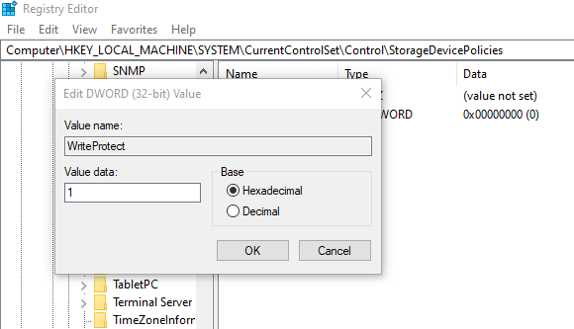
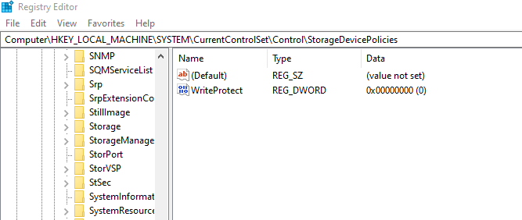

3.2 E01 Image Acquisition
Using FTK Imager, the physical drive was captured into the courtroom-preferred E01 (EnCase) format. This format was selected to embed crucial case metadata (Examiner, Case Number: CYB-W7-001, Notes) directly into the evidence file while supporting compression.
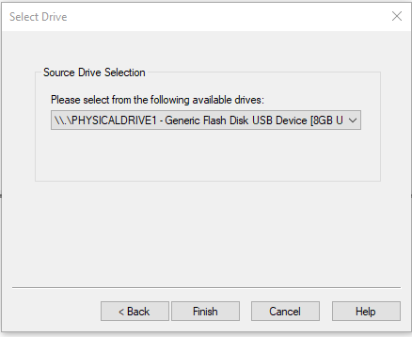
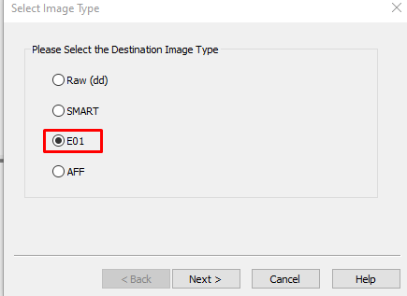

3.3 The FAT32 to NTFS Strategic Pivot
The initial acquisition was successfully performed against a FAT32-formatted volume. However, because FAT32 relies on a File Allocation Table rather than a Master File Table (MFT), advanced NTFS metadata analysis could not proceed.
To fulfill the operational objectives, a strategic pivot was executed: the target drive was reformatted to NTFS (Volume Label: EVIDENCE_01), seeded with new data, and securely re-imaged. The initial FAT32 image was retained for process integrity, while the new Week7_Evidence_USB_NTFS.E01 served as the authoritative image for all subsequent analysis.
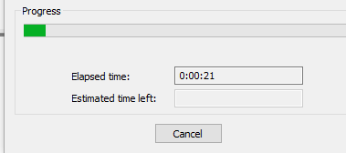
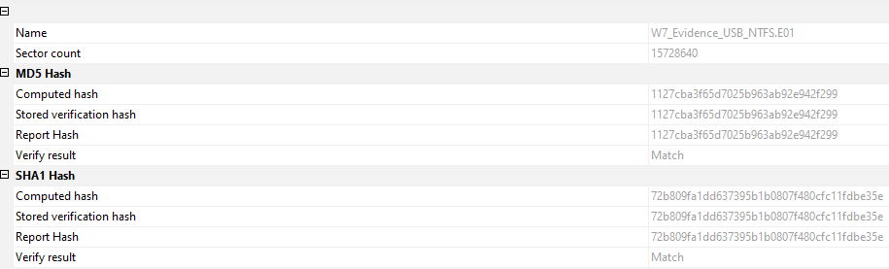

3.4 Read-Only Mounting
To verify the structural integrity of the E01 file without altering its contents, Arsenal Image Mounter was deployed in strict Disk device, read only mode.
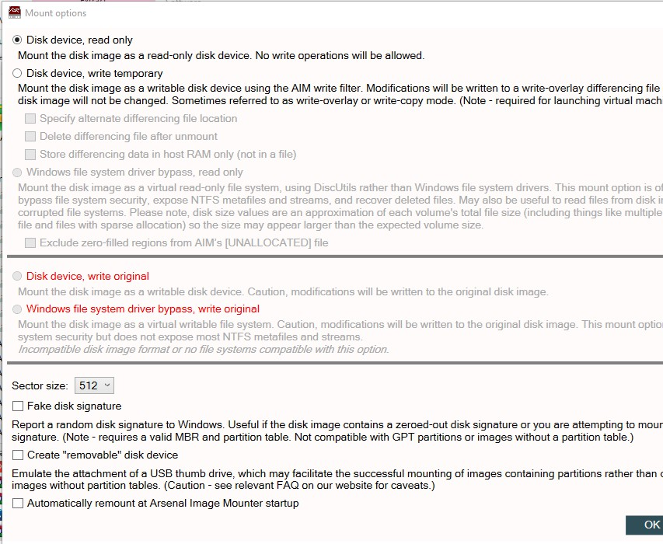

4. Phase II: File System Deep-Dive

4.1 Concealment via Alternate Data Streams (ADS)
Alternate Data Streams are a feature of NTFS that allow data to be attached to an existing file without affecting its size or visibility in standard file explorers—a common technique for concealing malicious payloads.
A visible file (visible_file.txt) was created. Using the command line, a hidden stream was appended using the syntax visible_file.txt:hidden_stream.txt.
Standard dir commands reported the file size as 30 bytes, showing no anomalies. However, utilizing the dir /r command and Sysinternals streams.exe, the hidden 159-byte payload ($DATA) was successfully detected and extracted.

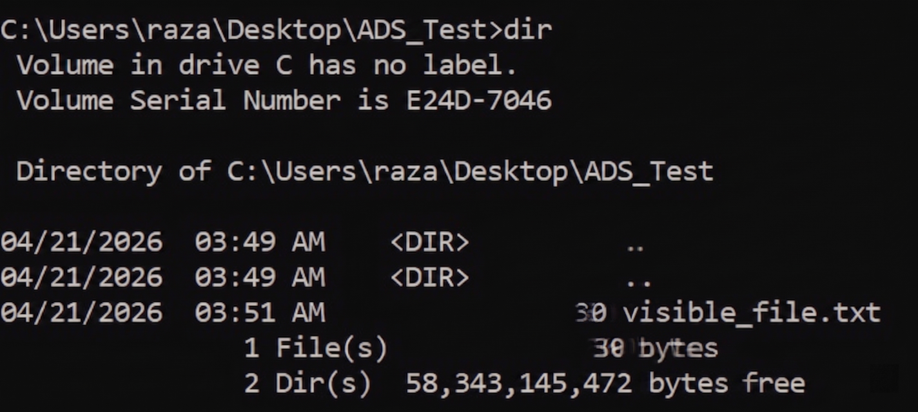
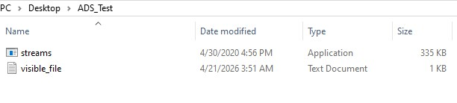

4.2 Legitimate ADS: Zone.Identifier
Not all ADS usage is malicious. The operating system utilizes the Zone.Identifier stream to flag files downloaded from the internet. Forensic analysis of a downloaded file (testing.doc) revealed a 211-byte $DATA stream containing this exact metadata, proving the file's origin.
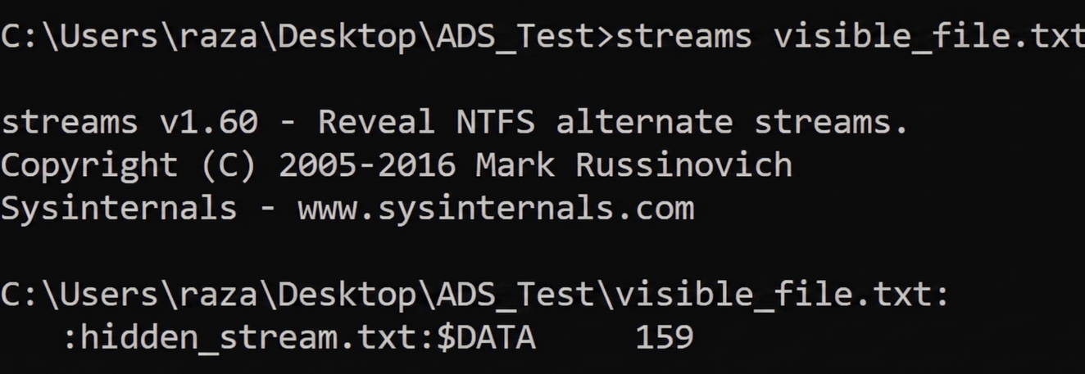

4.3 Master File Table ($MFT) Extraction & Analysis
The $MFT acts as the relational database for an NTFS volume, storing vital metadata for every file and folder. Using FTK Imager, the 256 KB $MFT file was exported from the root partition of the E01 image.
The exported table was parsed using MFT Explorer v2.1.0. Analysis of target files (e.g., image.jpg, notes.txt) revealed detailed $STANDARD_INFORMATION and $FILE_NAME attributes, alongside precise nanosecond-resolution MACB timestamps.
Crucially, analysis of the /personal/ directory revealed a deleted file (diary.txt). Despite being deleted, its MFT record remained intact with the Is Deleted flag set to True, demonstrating how NTFS preserves metadata until the specific MFT record is overwritten.
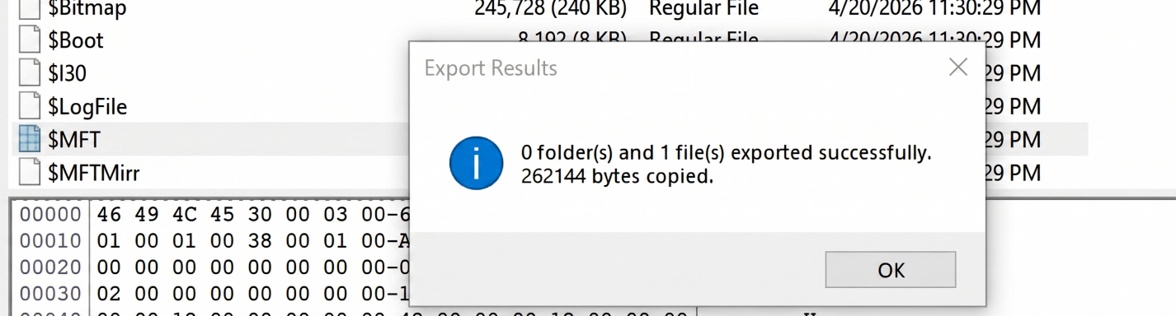

4.4 MACB Timestamp Methodology Experiment
To establish baseline expectations for timeline analysis, a controlled experiment was conducted to observe how Windows updates MACB timestamps across various file operations:
Operation Executed | Modified (M) | Accessed (A) | MFT Changed (C) | Born / Created (B)
File Creation | Set to creation time | Set to creation time | Set to creation time | Set to creation time
File Opened (No Edit) | No change | Updated | No change | No change
File Modified | Updated | Updated | Updated | No change
File Copied (New Loc.) | Preserved from source | Updated | Updated | Set to copy time
File Moved (Same Vol.) | No change | No change | Updated | No change

4.5 Comparative File System Architecture
Based on the week's research, the following outlines the forensic profiles of major file systems:
- NTFS (Windows): Highly structured via the $MFT. Deletion merely flags the record and frees clusters, making file recovery highly probable. Rich metadata environment (ADS, Journals).
- FAT32 (Legacy/Removable): Lacks an MFT. Uses directory entries and a File Allocation Table. Deletion replaces the first character of the filename with 0xE5. Data remains carved easily until overwritten.
- EXT4 (Linux): Relies on inodes. Deletion zeroes out block pointers, making raw data recovery significantly more challenging and destructive compared to NTFS.

5. Phase III: Automated Triage via Autopsy

5.1 Case Initialization & Ingestion
The authoritative NTFS E01 image was ingested into Autopsy 4.22.1 (Case: CYB_W7_USB_Investigation). Hash matching was independently confirmed by Autopsy upon import.
The following ingest modules were activated for maximum artifact extraction:
- Hash Lookup
- File Type Identification
- Keyword Search
- EXIF Parser
- Recent Activity
- PhotoRec Carver
- Extension Mismatch Detector

5.2 Forensic Findings & Data Recovery
Autopsy’s automated triage successfully reconstructed several high-value artifacts from unallocated space.
- Deleted Documents: report.docx.docx (12,746 bytes) and diary.txt.txt (27 bytes) were identified as Unallocated. Using the Extracted Text view, the content of both files was fully reconstructed (e.g., "Private notes - do not read").
- File Carving & Mismatches: A carved duplicate of spreadsheet.xlsx was recovered. The Extension Mismatch Detector successfully flagged anomalies in file headers.
- Web Download Artifacts: The Recent Activity module automatically flagged image.jpg, extracting its original source URL (hdqwalls.com) via the Zone.Identifier stream previously studied manually.
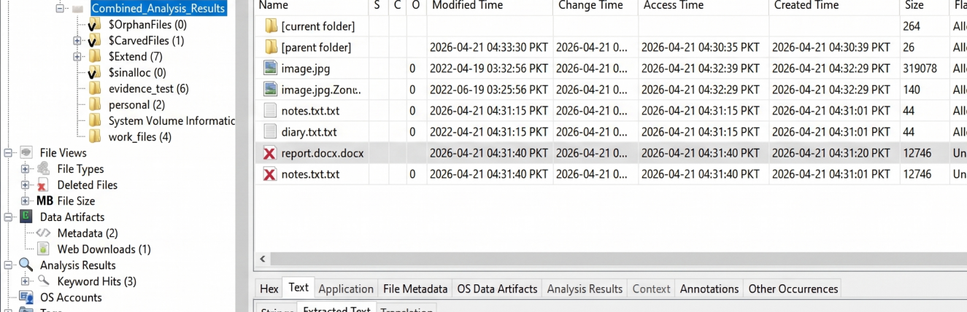

5.3 Timeline Analysis & Reporting
Autopsy’s Timeline module mapped all NTFS metadata events ($LogFile, $BadClus, $Extend, etc.). Two distinct clusters emerged:
- June 2022: Correlating with the historical creation metadata of the imported image files.
- April 2026: A dense cluster of 20 events reflecting the intentional forensic seeding and deletion activities.
Finally, an automated HTML Forensic Report was generated, encapsulating the case data, hashes, and carved files.

6. Executive Conclusion & Lessons Learned
Week 7 effectively bridged the gap between theoretical file system structures and practical forensic extraction. Key takeaways include:
- The Necessity of Write-Blocking: Without hardware or software write-blocking, the host OS will instantly contaminate evidence by altering Access timestamps and creating hidden system files (e.g., System Volume Information).
- Hash Integrity: Cryptographic hashes are the bedrock of forensic admissibility. Proving that the E01 hash matches the physical drive hash guarantees zero spoliation.
- The Illusion of Deletion: Standard deletion methods in NTFS and FAT32 merely update pointers and flags (like the MFT Is Deleted state or the 0xE5 FAT marker). The actual payload remains perfectly intact and recoverable until physically overwritten, as demonstrated by the Autopsy recovery of diary.txt.

Appendix A: Evidence Log Summary
Artifact Path | Type | State | Significance
/evidence_test/image.jpg | JPEG | Allocated | Base media file for ADS testing.
/evidence_test/image.jpg:Zone.Identifier | ADS / Text | Allocated | Confirms file downloaded from Internet Zone.
/evidence_test/report.docx.docx | DOCX | Unallocated | Deleted document; Autopsy reconstructed text successfully.
/personal/diary.txt.txt | Text | Unallocated | Deleted text file; contents successfully recovered.
/work_files/spreadsheet.xlsx.pub | Spreadsheet | Unallocated | Carved duplicate flagged by Extension Mismatch Detector.

Appendix B: Formal Chain of Custody
Field | Details
Case Number | CYB-W7-001
Evidence Item | USB Flash Drive
Evidence Number | E001
Description | USB Flash Drive — NTFS formatted, EVIDENCE_01 volume label
Manufacturer/Model | Generic Flash Disk USB Device / 0
Date of Acquisition | 21 April 2026
Examiner Name | Abdul Muqeet Tabraiz
Organization | Cyberster Blue Team Internship
Write-Block Method | Software — Windows Registry WriteProtect = 1
Image Format | E01 (EnCase format)
Image File Path | D:\Cyberster-Blue-Team-Internship\Week 7\Screenshots\Week7_Evidence_USB_NTFS.E01
Hash Verification | MD5 & SHA-1 Match Confirmed (Values logged in Section 1.2)
Storage Location | D:\Cyberster-Blue-Team-Internship\Week 7\Screenshots
Examiner Notes | Drive initially FAT32-imaged, then reformatted to NTFS and re-imaged for MFT analysis. Both images retained. Software write-protection used in lieu of hardware write-blocker — disclosed as limitation.

